**Web Designing assignment**

**MODULE: 2 (CSS and CSS 3)**

* **What are the benefits of using CSS?**
* **There are a number of benefits of CSS, including:**
* **Faster page speed**
* **Better user experience**
* **Quicker development time**
* **Easy formatting changes**
* **Compatibility across devices**
* **What are the disadvantages of CSS?**
* **These are CSS disadvantages.**
* **Security issues**
* **Creates confusion**
* **Cross-browser issues**
* **Differences in display**
* **What is the difference between css2**

**and css3?**

* **In CSS2, everything is present in a single document while CSS3 is categorized into multiple sections called modules.**
* **Graphics-related features such as Box-shadow or Border-radius, flexbox, etc.**
* **can be found which are absent in case of CSS2.**
* **Properties such as background-position, background-image, and background-repeat styles can be helpful for using multiple background images in a single webpage.**
* **CSS3 versions support many new browsers.**
* **CSS3 introduces many new selectors in the form of pseudo-elements and pseudo-classes.**
* **Name of few style components.**
* **A few CSS style components include Property, Value, and Selector.**
* **What do you understand by CSS opacity?**
* **The opacity property sets the opacity level for an element.**
* **The opacity-level describes the transparency-level, where 1 is not transparent at all, 0.5 is 50% see-through, and 0 is completely transparent.**
* **When using the opacity property to add transparency to the background of an element, all of its child elements become transparent as well.**
* **How can the background color of an element be changed?**
* **Add the style attribute to the <body> element You can set a background color for an HTML document by adding style="background-color:" to the <body> element.**
* **Add the CSS background-color property to the <body> element The background-color property is used to change the background color.**
* **How can image repetition of the backup be controlled**?
* **Background-repetition property controls the repetition of images in the background.**
* **Use no-repeat if the image is to be displayed once in the background.**
* **What is the use of the background-position property?**
* **The background-position property in CSS is mainly used to sets the initial position for the background image.**
* **it is used to set an image at a certain position. The position that is relative to the positioning layer, can be set by using the background-origin property.**
* **Which property controls the image scroll in the background?**
* **The**[***background-attachment***](https://www.geeksforgeeks.org/css-background-attachment-property/)**property in CSS is used to specify the kind of attachment of the background image with respect to its container.**
* **It can be set to scroll or make it remain fixed.**
* **It can be applied to all**[**HTML**](https://www.geeksforgeeks.org/html/)**elements.**
* **Why should background and color be used as separate properties?**
* **This is done with mainly two purposes:**
* **It makes the style sheets more legible. Background property, which is complex in itself, becomes all the more complex with color.**
* **Color is an in-built property while the background is not one. And this can lead to a lot of confusion.**
* **How to centre block elements using CSS1?**
* **In order to centre the block-level elements, we need to set the margin-right and margin-left properties to explicit values.**
* **How to maintain the CSS specifications?**
* **The CSS specifications are maintained by the World Wide Web**
* **Consortium (W3C).**
* **The four types of specifying are: descriptive, performance, reference standard, and proprietary.**
* **Cascading Style Sheets (CSS) is a stylesheet language used to describe the presentation of a document written in HTML or XML.**
* **What are the ways to integrate CSS as a web page?**
* **There are three methods to integrate CSS in the form of a web page:**
* **Embedded: There can be a style element inside the head element inside which we can place the code.**
* **Inline: CSS can be applied directly to HTML elements using attributes.**
* **Imported or Linked: In the case of linked or imported CSS, the CSS is placed in an external file and a link element is used to link it.**
* **What is embedded style sheet?**
* **These are the sheets where style sets for the entire HTML document are defined in a single place.**
* **For doing this, the style sheet information under the style tags should be embedded into an HTML document**
* **What are the external style sheets?**
* **External style sheets are sheets used externally which can be linked to the HTML pages.**
* **What are the advantages and disadvantages of using external style sheets?**
* **Advantages:**
* **There can be many documents for multiple HTML elements, along with many classes.**
* **Multiple documents with various styles can be controlled using different styles.**
* **Selector and grouping methods can be used for grouping styles in composite situations.**
* **Disadvantages:**
* **For rendering the document, external style sheets have to be loaded.**
* **It is not suitable for small style definitions.**
* **For importing documents with style information, an additional download is required.**
* **What is the meaning of the CSS selector?**
* **A CSS selector is the first part of a CSS Rule.**
* **It is a pattern of elements and other terms that tell the browser which HTML elements should be selected to have the CSS property values inside the rule applied to them.**
* **The element or elements which are selected by the selector are referred to as the subject of the selector.**
* **The selector in CSS is used for the purpose of linking HTML and style sheet elements — just like string in HTML.**
* **What are the media types allowed by CSS?**
* **CSS allows different media types, including speech, audio, visual and tactile media, paged or continuous media, bitmap or grid media, and even interactive media.**
* **What is the rule set?**
* **Rulesets can be used to identify selectors attached to one another.**
* **It consists of two different parts - selector and declaration.**
* **Create Layouts**
* **A website is often divided into headers, menus, content and a footer:**

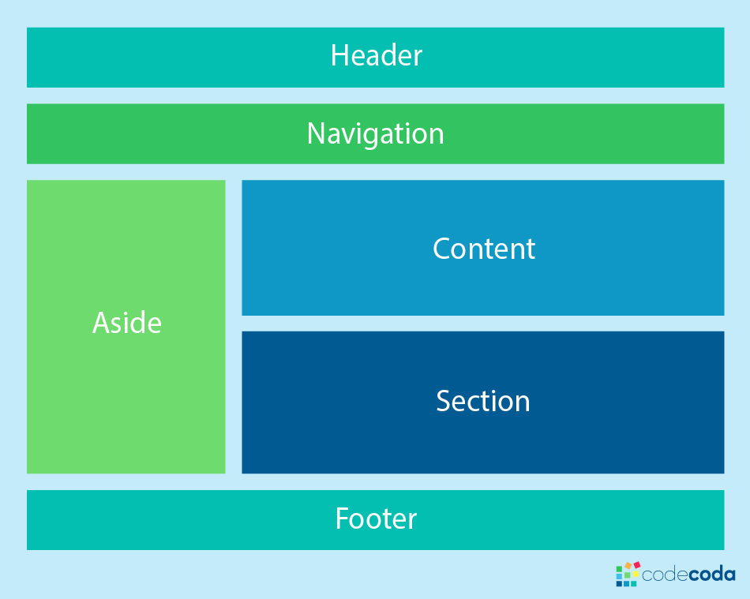

## **Header**

* **A header is usually located at the top of the website (or right below a top navigation menu). It often contains a logo or the website name:**

**Ex;**

**header {  
  background-color: #F1F1F1;  
  text-align: center;  
  padding: 20px;  
 }**

* **Navigation bar**
* **A navigation bar contains a list of links to help visitors navigating through your website**
* **Content**
* **The layout in this section, often depends on the target users. The most common layout is one (or combining them) of the following:**
* **1-column (often used for mobile browsers)**
* **2-column (often used for tablets and laptops)**
* **3-column layout (only used for desktops**
* **Footer**
* **The footer is placed at the bottom of your page. It often contains information like copyright and contact info:**

**Ex;**

**footer {  
  background-color: #F1F1F1;  
  text-align: center;  
  padding: 10px;  
 }**